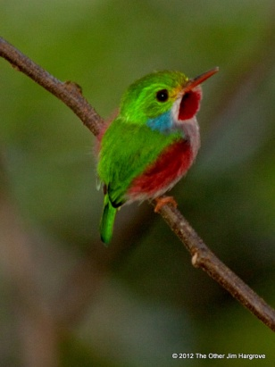
Hargrove Annual Report for 2012

Jim and Linda Travel Some More
Determined to pack as many trips as possible into our time left for birding travel, we upped the ante this year. Early in 2012, we traveled to Cuba (link to file on website) with National Audubon (who also provided a report), then spent 3 weeks birding in Borneo and the Malay Peninsula.
We ended 2012 in the air, on our way to Jakarta, a trip that didn't turn out as planned.
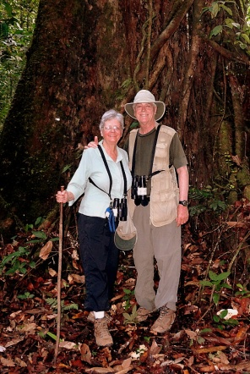
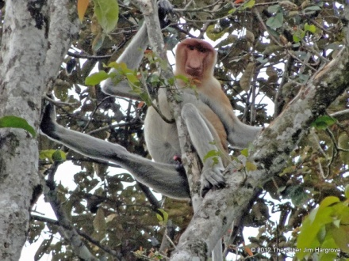
In Cuba, we met with several local environmentalists, a requirement of the visa we had. Trips to Cuba are only available when a significant amount of time is devoted to person-to-person contact. We had some nice looks at several Cuban endemics. Everyone's favorite was the spectacular Cuban Tody, one of five members of that family in the world. All are found in the Caribbean.
A hot and strenuous trip to Borneo and Malaysia rewarded us with great views of special birds and mammals, such as the Proboscis Monkey at right. Borneo proved to be a great place to photograph bugs. For more interesting bugs are in our Bug Photos spread.
We also traveled to Houston—to use our last two tickets for the Houston Ballet—and to Austin to visit friends. We also attended Rice University’s Centennial celebration in October.

Life on the Left Coast
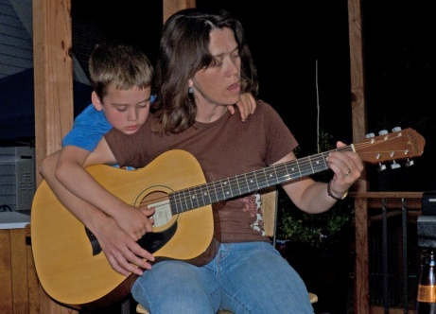
It’s been a year since we left Texas for California, and we are almost used to our new environs. The garden is taking shape nicely, thanks to Linda and gardening crew. The birds have found our feeder. Our neighbors are all nice, and despite the “Caution Children Playing” sign at the entrance to our little enclave, most are our age. We have many marvelous parks and coastline to explore. We have found several birding groups, including three different local Audubon Societies and an informal Tuesday for the Birds bunch. Jim has found some new bridge partners, though his association with Bob Arnett is still the best source of master points, resulting in his becoming a Bronze Life Master. Linda joined a Book Club. Jim plays tennis with a bunch of old guys (60+ years old) while Linda goes to Yoga classes and rides the stationary bike for exercise.
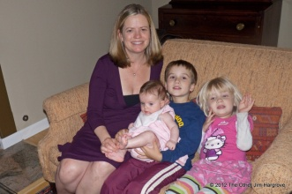
Of course, moving here was all about grandkids. All are doing fine. At left is a photo of Kai and Amy practicing guitar in Philo. The photo on the right shows Claire with all three grandkids on Mother’s Day.

Charles and Amy, Kai and Kiera
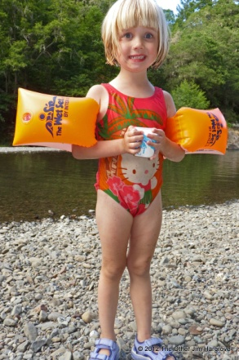
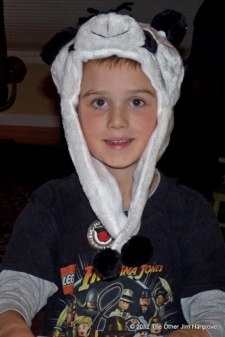
Charles continues to work four days a week at NCSE, while Amy works as a Women’s Health Care NP and Nurse Midwife. She has delivered 1040 babies in her career. Her record is seven deliveries in one 12-hour shift!
After successfully remodeling the kitchen and nearby parts of their house, Charles and Amy discovered that the original bathroom was also in need of an update. The results are excellent, so much so that Kai has graduated to showers instead of tub baths, thanks to controls low enough for him to reach.
Amy helps both kids with their projects and Charles bikes with them in their neighborhood. Kiera takes art classes once a week, while Kai is learning to play the guitar.
Kiera is becoming an enthusiastic budding entomologist, which delights her grandfather. Here is a photo of her in the Navarro River near Philo, with a cupful of creatures from the river.

Claire and Ron, Scarlet and ???
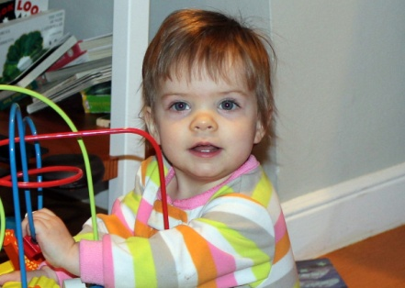
Claire and Ron are both doing well, and expecting a baby per scheduled C-Section on June 4, 2013. Scarlet turned one on December 30, 2012. She is just on the verge of walking. She doesn’t seem close to mastering “Granddad,” but her babbling sometimes sounds like “Nana.”
With another child on the way, Claire and Ron decided the condo in San Francisco was too small. They found another in the Potrero Hill area with 3 bedrooms and more importantly 2 ½ bathrooms. The new condo allows Ron to walk to work, and shortens Claire’s commute to Childrens Hospital in Oakland.

Granny’s Milestones
In September, we returned to Houston to celebrate Marion’s (Granny’s) 90th birthday. We gathered all her great grandchildren together for a group photo. (Below left.)
In case you were wondering, Jim is still nuts about spiders. He found the one shown below in Borneo particularly lovely.
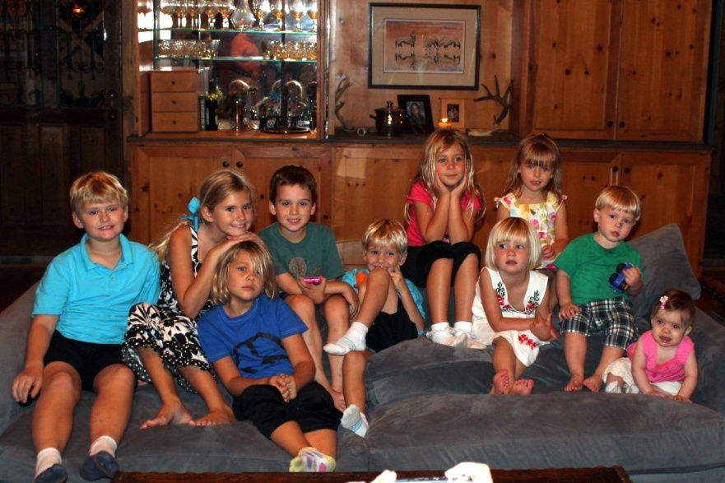
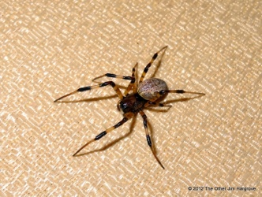
We hope you are as happy and healthy as we. Check out hargrove.org for the complete story of 2012. We would love to welcome you to visit the San Francisco Bay Area. Six couples visited us in 2012, and we loved every minute.

